What is Python?

Python is a popular programming language. It was created by Guido van Rossum, and released in 1991.

It is used for:

* web development (server-side),
* software development,
* mathematics,
* system scripting.

Python works on different platforms (Windows, Mac, Linux etc)

* Python runs on an interpreter system, meaning that code can be executed as soon as it is written. This means that prototyping can be very quick.
* Python can be treated in a procedural way, an object-oriented way or a functional way.
* Python relies on indentation, using whitespace, to define scope; such as the scope of loops, functions and classes. Other programming languages often use curly-brackets for this purpose.

Installing Python ? Do Developers do installations/upgrades in real projects ?

Yes – In most teams development Teams take care of installing /upgrading the runtimes Ex: python , java upgrades etc.

They may provide instructions to teams who have access to PROD servers as in most cases dev team would not have access to login to prod servers.

These are done during specialized windows called Releases where all changes are documented and sent to stakeholders

Installing Python

* Go To <https://www.python.org/downloads/>
* Download the latest version

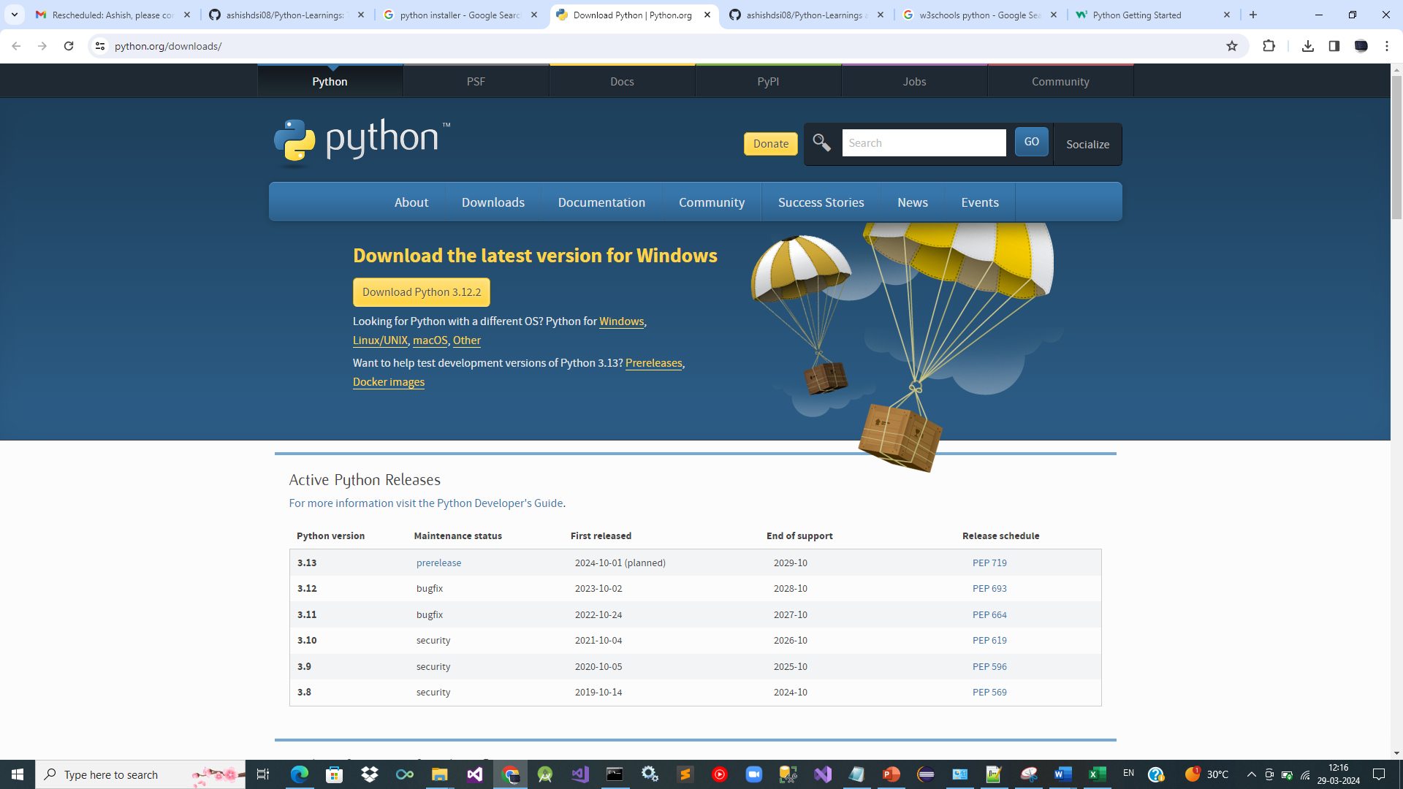



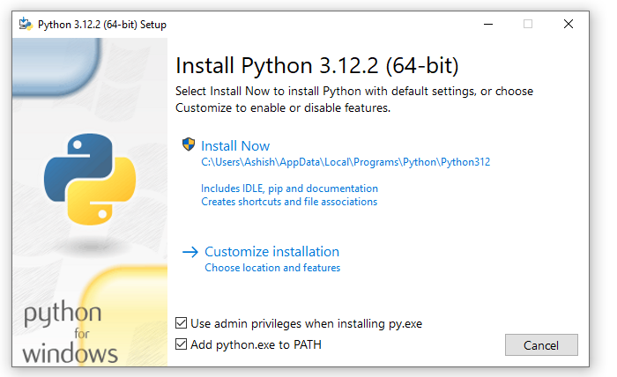

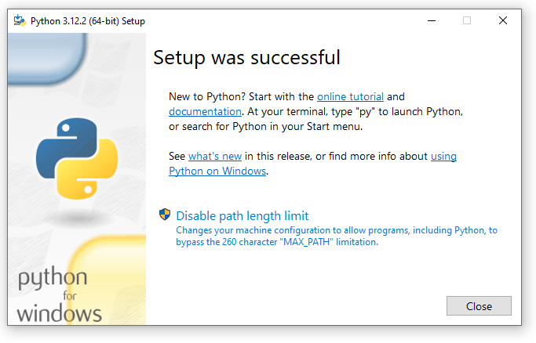

**Install Location :** C:\Users\Ashish\AppData\Local\Programs\Python\Python312

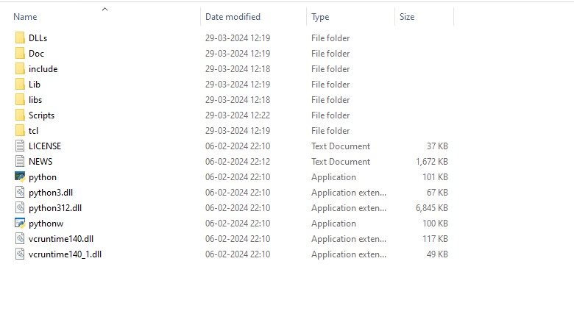

Check Python Version : python –version

